Ideation Phase
Define the Problem Statements

Date | 12 October 2026
Team ID | 323103282097.aswija@gvpcew.ac.in
Project Name | ServiceNow Employee Raise Issue Portal
Maximum Marks | 2 Marks

Customer Problem Statement – Employee Raise Issue

Project context: Employees in a large enterprise may report workplace issues such as access problems, infrastructure requests, payroll discrepancies, or HR policy questions through emails and informal channels. The supplied problem statement identifies inconsistent data capture, delays, limited status visibility, manual effort, and inconsistent prioritization/assignment.
Customer Problem Statement Canvas
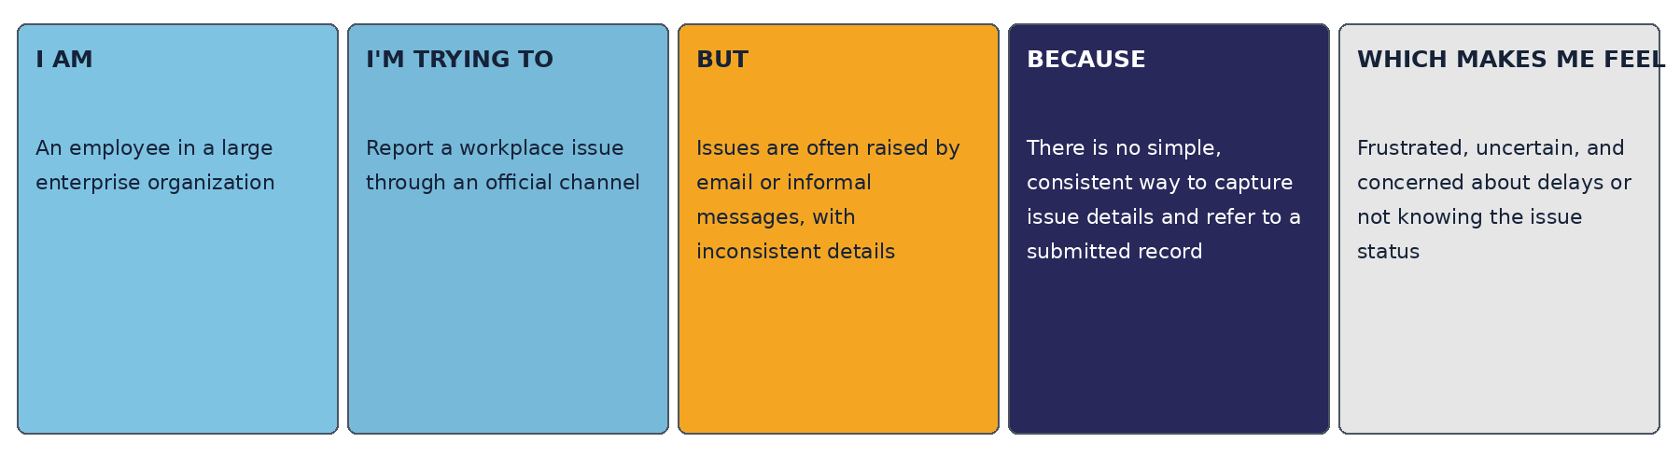
Problem Statement (PS-1)
Problem Statement (PS) | I am (Customer) | I'm trying to | But | Because | Which makes me feel
PS-1 | An employee in a large enterprise organization | Report a workplace issue through a standard, official portal | Issues are often reported through emails or informal channels with inconsistent details and limited status visibility | There is no consistent, easy-to-use intake process for capturing issue details and creating a traceable record | Frustrated and uncertain about delays, follow-up, and whether the issue is being handled
Problem Statement (PS-2)
Problem Statement (PS) | I am (Customer) | I'm trying to | But | Because | Which makes me feel
PS-2 | An employee who needs technical or workplace support | Submit clear issue details and refer to the report later | The employee may not know the correct category/subcategory or how to provide enough context | Informal reporting does not consistently guide the employee through structured fields and optional supporting evidence | Confused while reporting and concerned that the issue may be misunderstood
Solution alignment: The implemented Employee Center portal provides a Raise an Issue entry point and a Record Producer that captures requester name, category, subcategory, short description, issue state, and optional attachment, then creates a record with a generated ticket number. The document does not assume unverified automatic assignment, notifications, or resolution-time guarantees.

